|  |
| --- |
| **Cinema Management System** |

**Contents**

1. Project Definition: 2

2. Project ERD: 3

3. Schema: 4

4. Project TABLE CREATE 5

4.2. Create Table Admin 6

4.3. Create Table Shows 7

4.4. Create Table Theater 8

4.5. Create Table Movie 9

4.6. Create Table Seats 10

4.7. Create Table Ticket 11

4.8. Create Table Ticket_location 12

5. Project TABLE INSERT 13

5.1 Insert Into Admin Table 13

5.2 Insert Into Shows Table (Start Time And End Time) 14

5.3 Insert Into Theater Table Theater Name 15

5.4 Insert Into Movie Table (Movie Name & ID) 16

5.5 Insert Into Seats Table 17

5.6 Insert Into Ticket Table 18

5.7 Insert Into Ticket_location Table 19

6 Project TABLE GROUP BY & JOIN 20

6.1 GROUP BY Admin_ID 20

6.2 GROUP AVG Price BY Admin_ID 21

6.3 GROUP Sum Price BY Admin_ID 22

6.4 JOIN Movie Table and Show Table BY Show_ID 23

6.5 INNER JOIN Seats ON Theater 24

# **Project Definition:**

Our project represents a simple database of a cinema management system.

**We have the main entities that are present in such a system with their respective attributes:**

* Admin

(Who controls the system at the ticket window)

* Shows

(Represents the show ID, start and end time)

* Theater

(Represents the theater ID and the theater name)

* Movie

(Represents the available show that has the movie ID, the movie name)

* Seats

(Represents the seat ID that belongs to the theater)

* Ticket

(Represents the whole data on the ticket: ticket ID, the date they booked the ticket, the seat number, the ticket price, which admin reserves the ticket, the chosen show and which theater will present the movie)

* Ticket_location

(Describes the location of the theater place in the hall, all along the ticket ID and which admin has booked the ticket)

**Our project has the following relationships:**

* An admin can book more than one ticket.
* A theater can have more than one ticket.
* A show can have more than one ticket.
* A theater has many seats.
* A show can have more than one movie.

# **Project ERD:**

Figure 1 - Cinema Management System ERD

# **Schema:**

**Admin (**admin_id, admin_name, admin_age, admin_address**)**

**Shows (**show_id**,** end_time**,** start_time**)**

**Movie (**movie_id**,** movie_name**,** show_idFK**)**

**Theater (**theater_id**,** theater_name**)**

**Seats (**seat_id**,** theater_idFK**)**

**Ticket (**ticket_id**,** booking_date**,** seat_no**,** price**,** admin_idFK**,** show_idFK**,** theater_idFK**)**

**Ticket_location (**hall_location**,** ticket_id**)**

# **Project TABLE CREATE**

4. 1. **Create Database Schema**

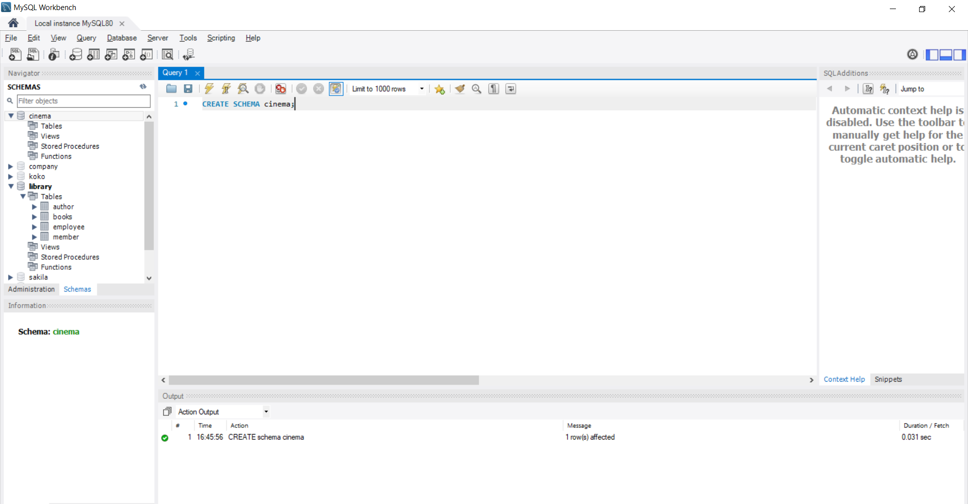

## **Create Table Admin**

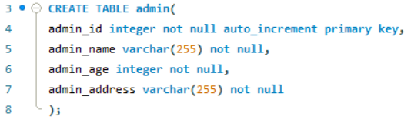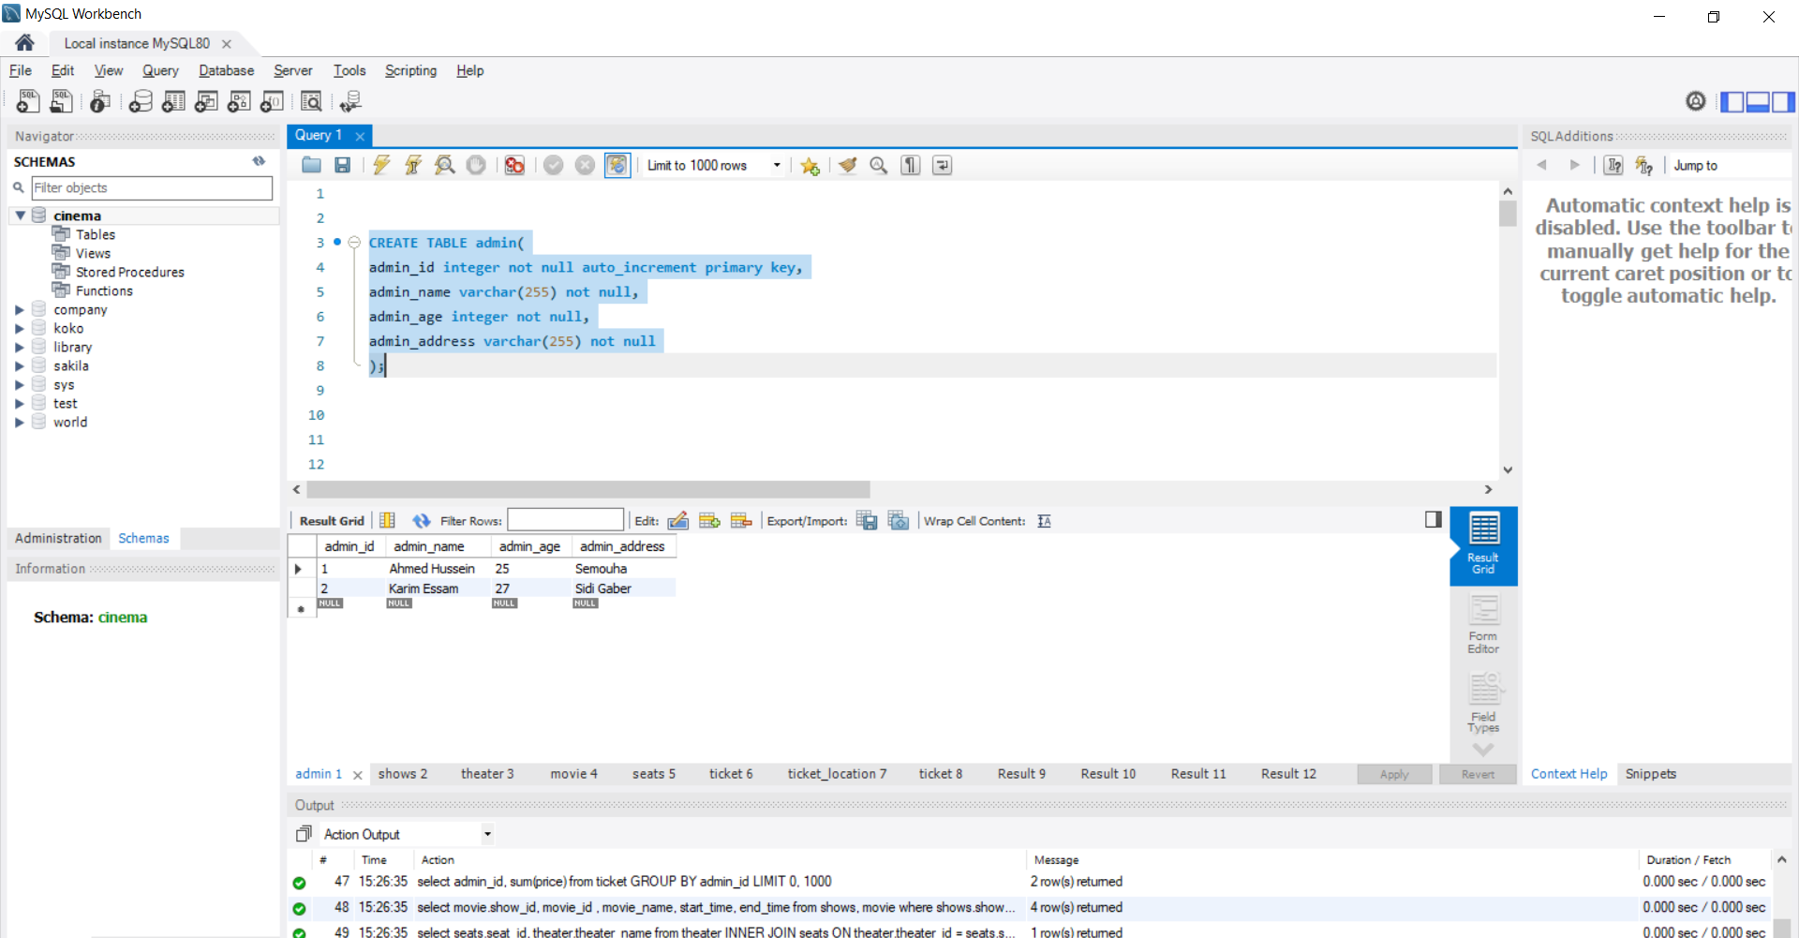

## **Create Table Shows**

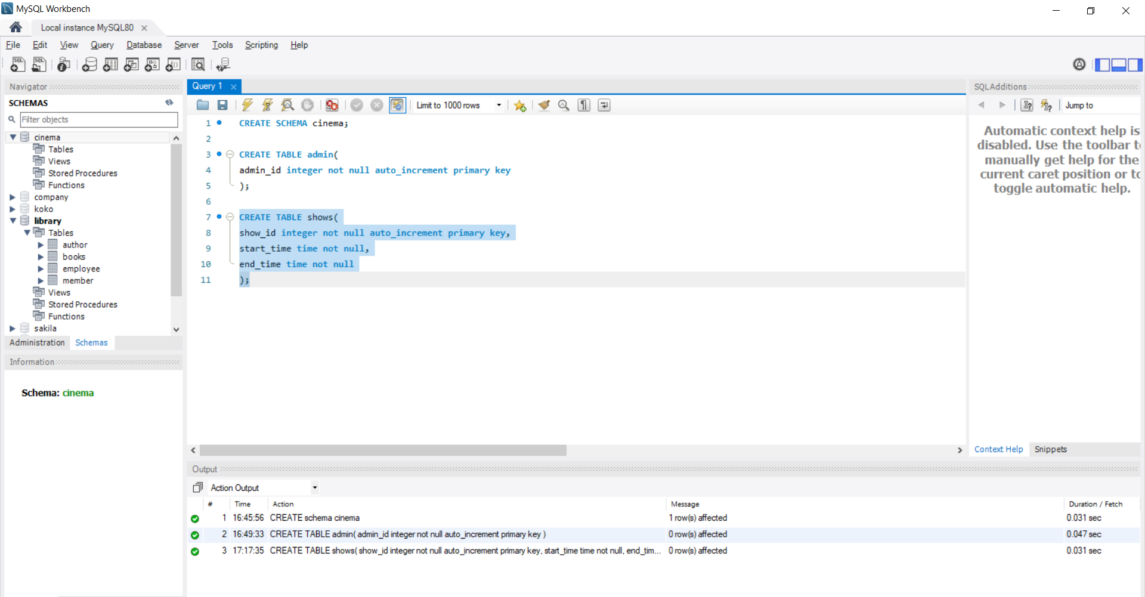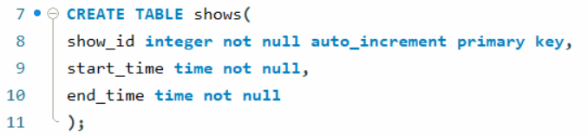

## **Create Table Theater**

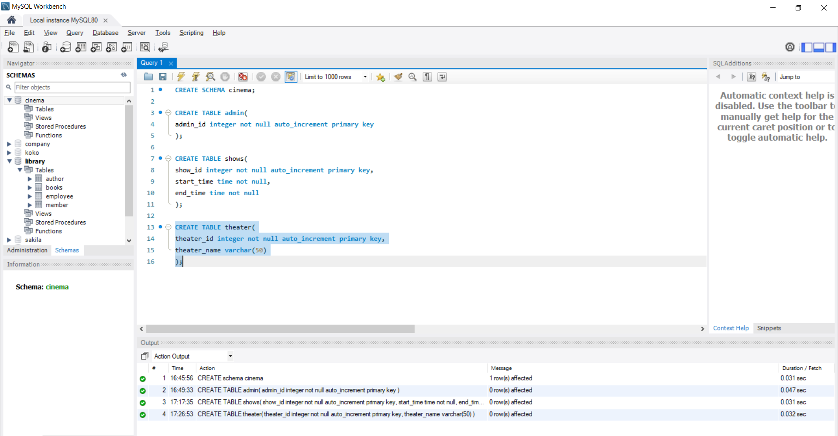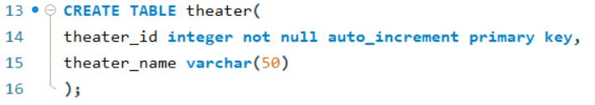

## **Create Table Movie**

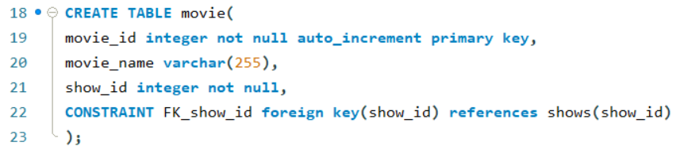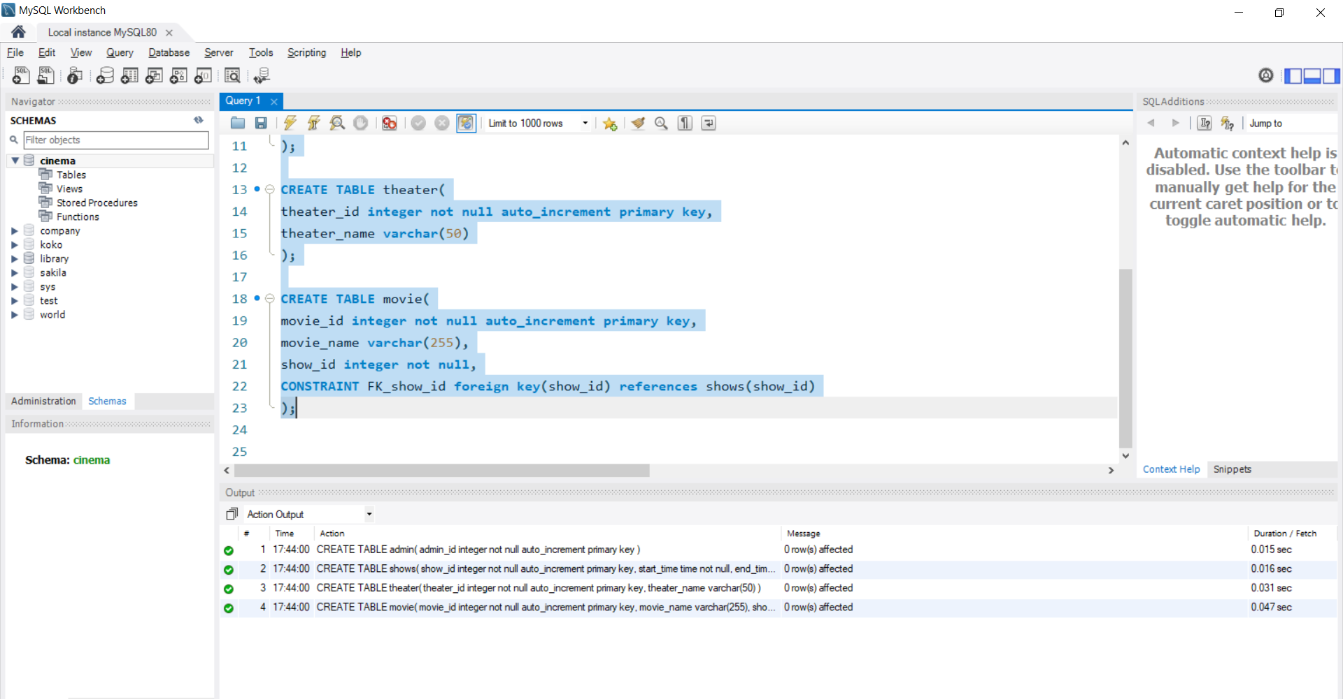

## **Create Table Seats**

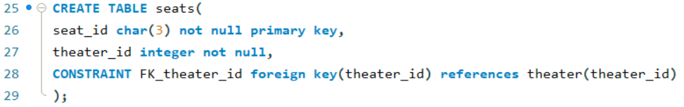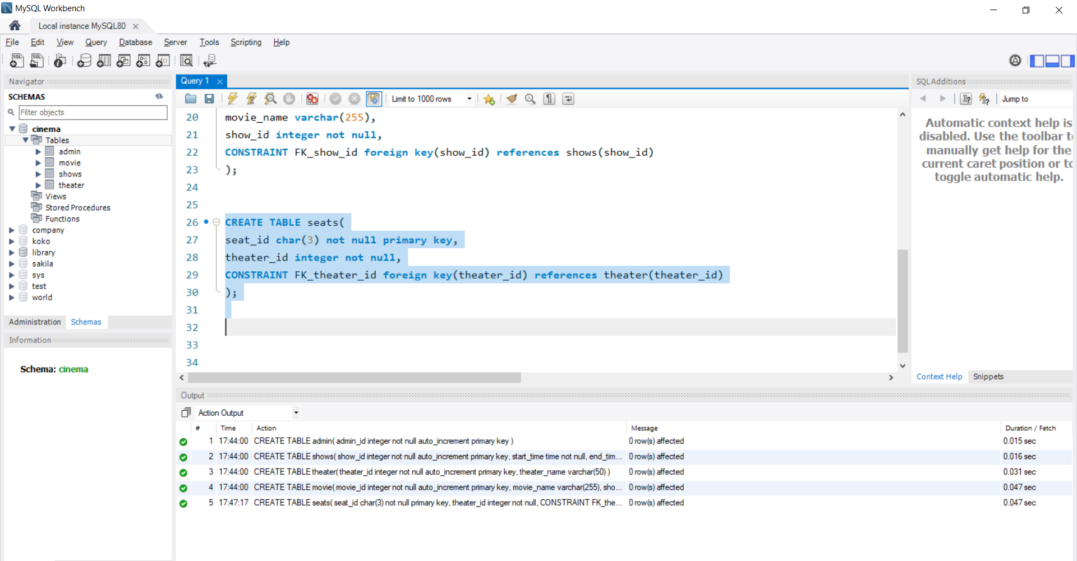

## **Create Table Ticket**

## **Create Table Ticket_location**

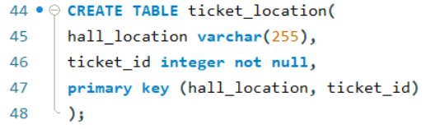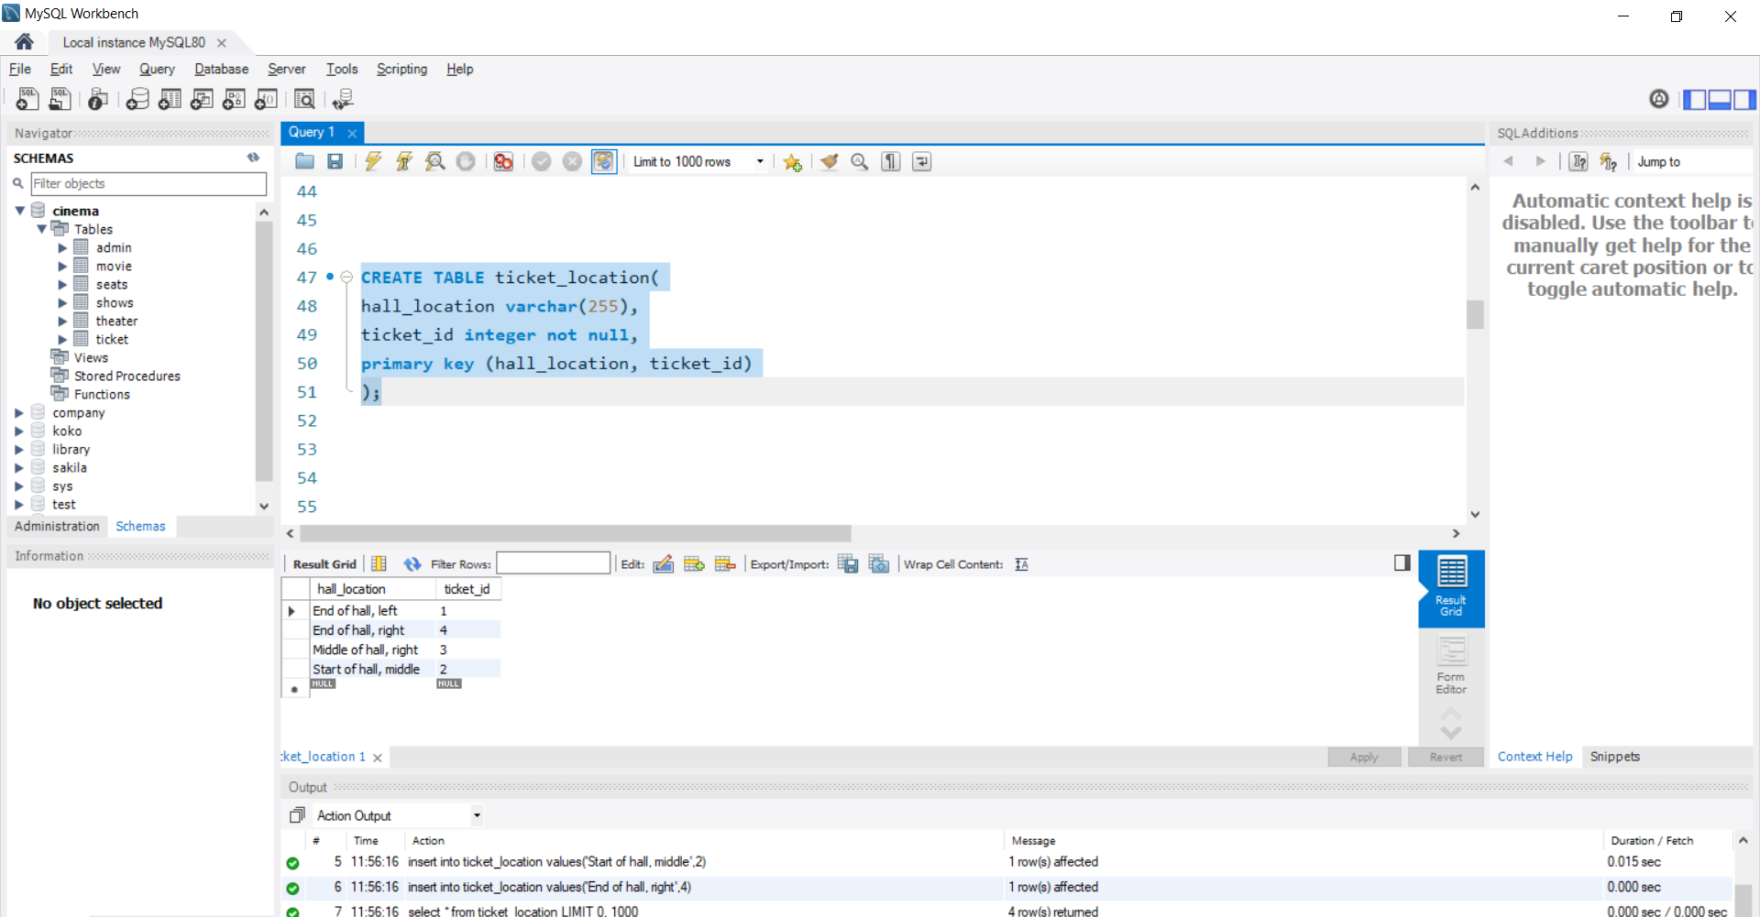

# **Project TABLE INSERT**



## **Insert Into Admin Table**

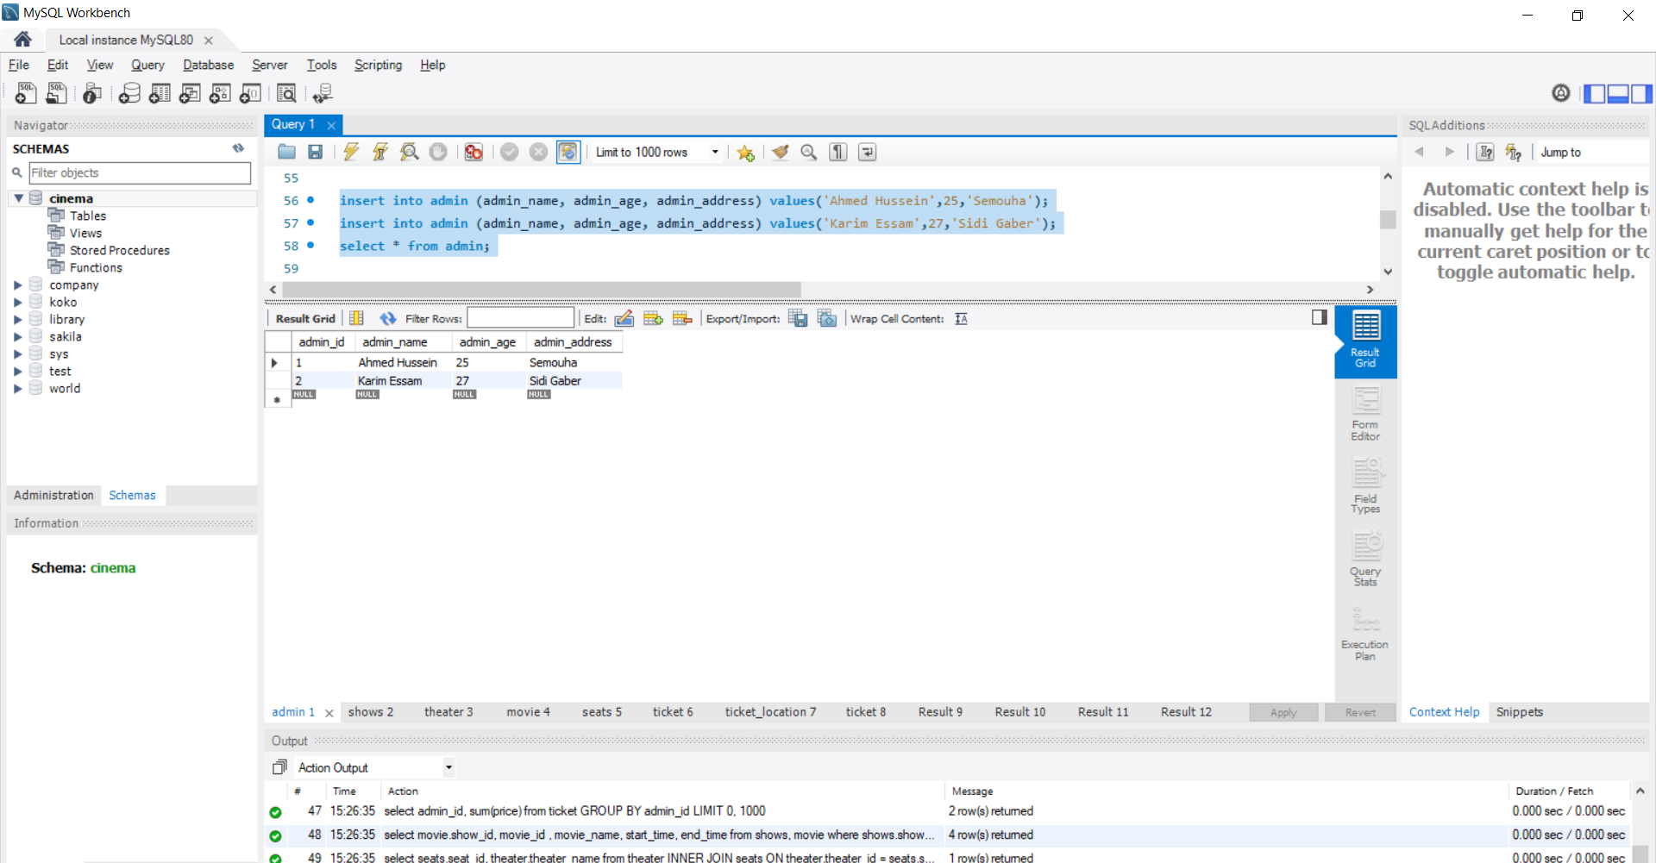

## **Insert Into Shows Table (Start Time And End Time)**

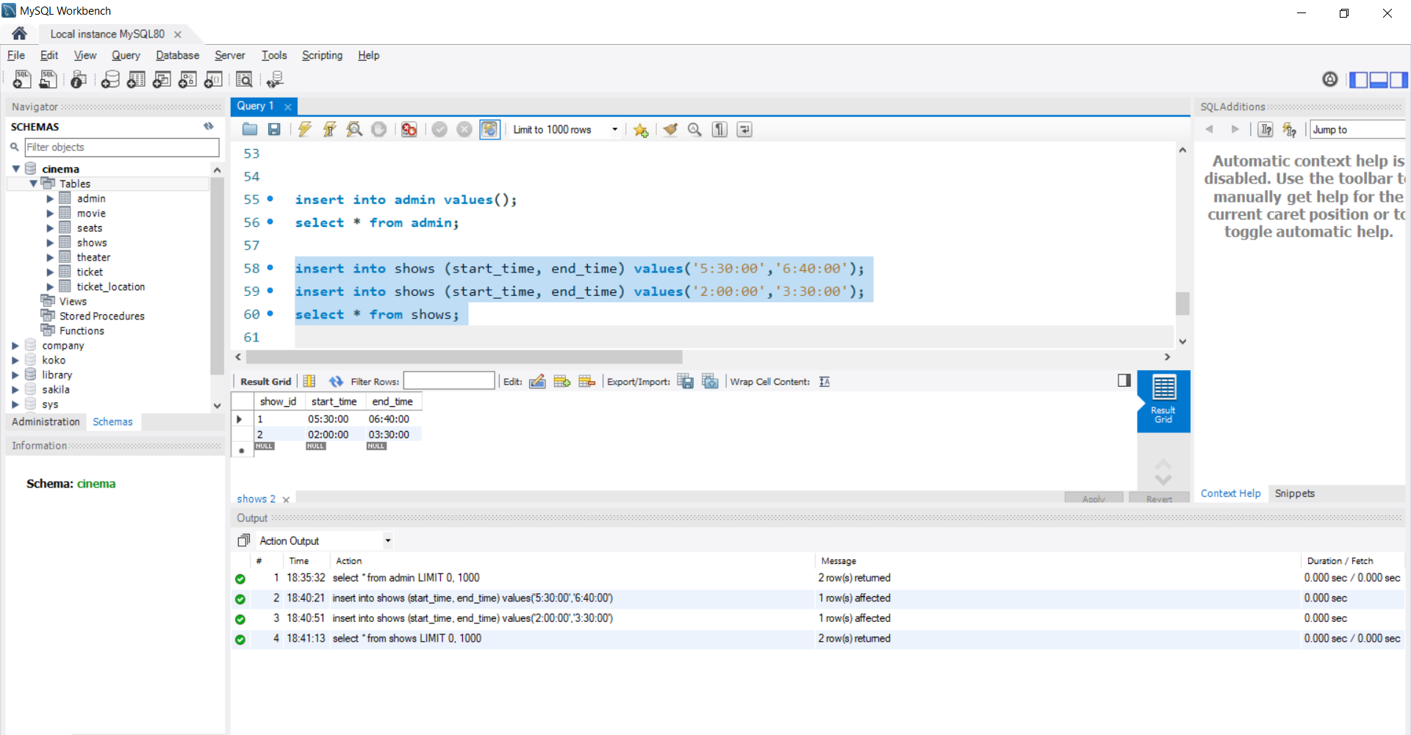

## **Insert Into Theater Table Theater Name**

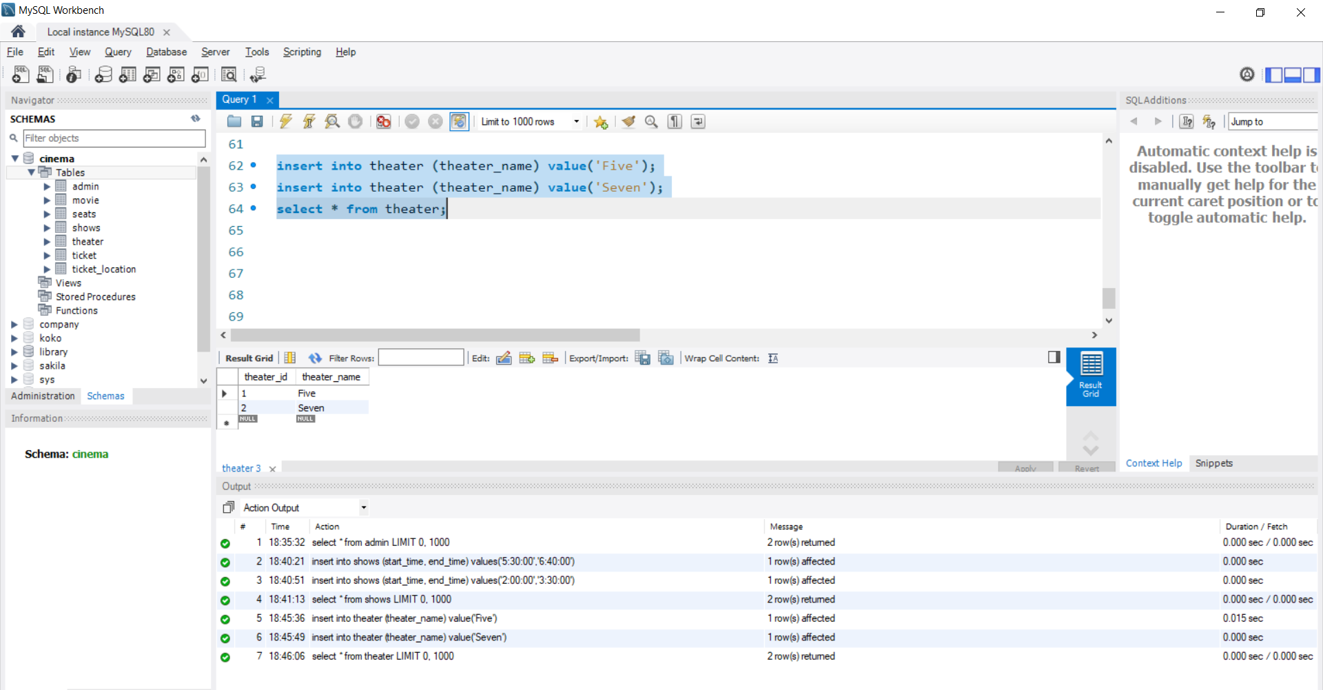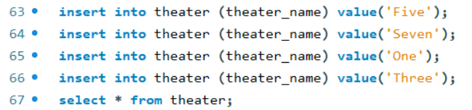

## **Insert Into Movie Table (Movie Name & ID)**

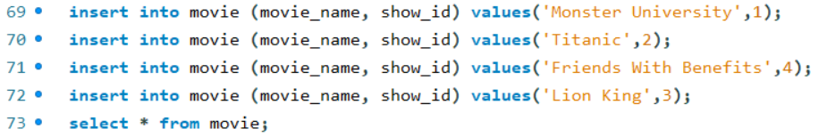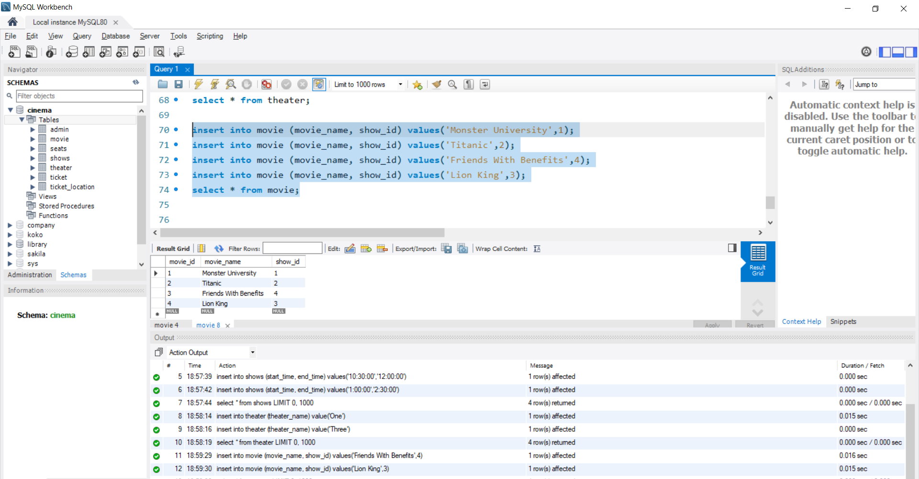

## **Insert Into Seats Table**

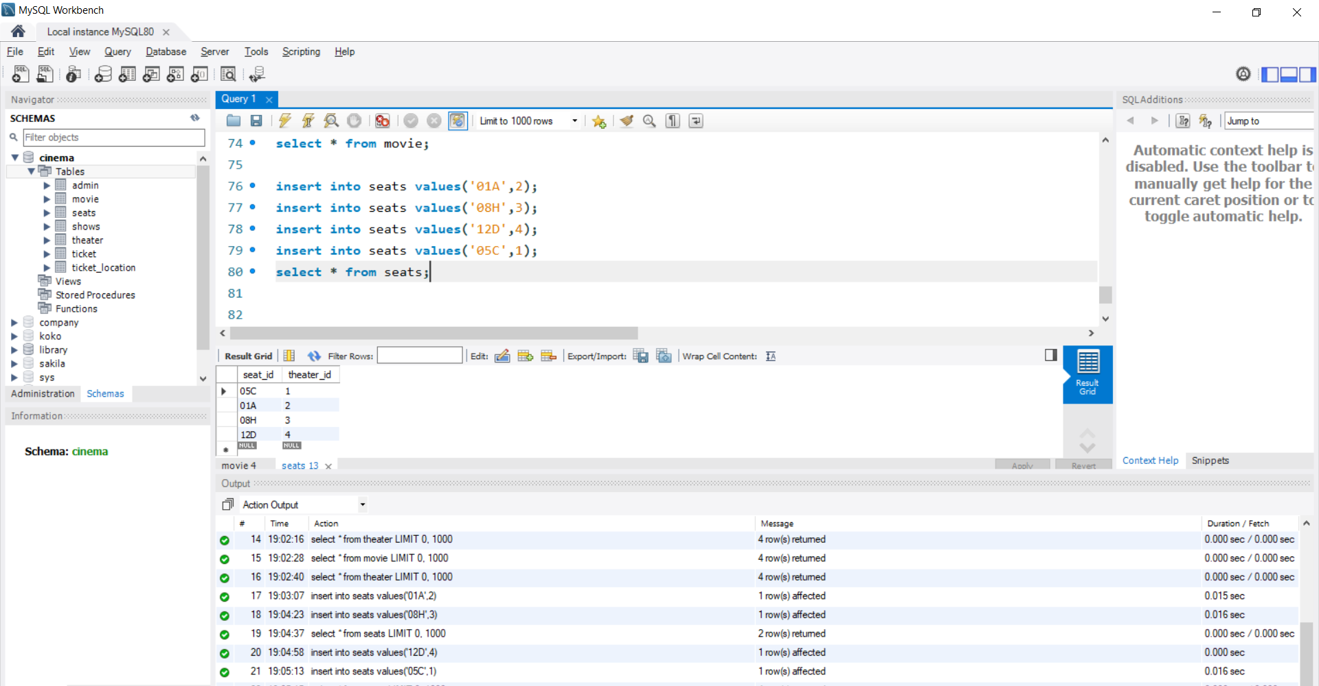

## **Insert Into Ticket Table**

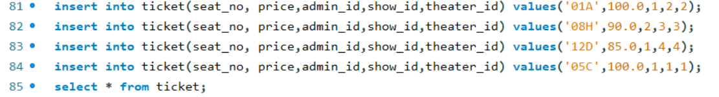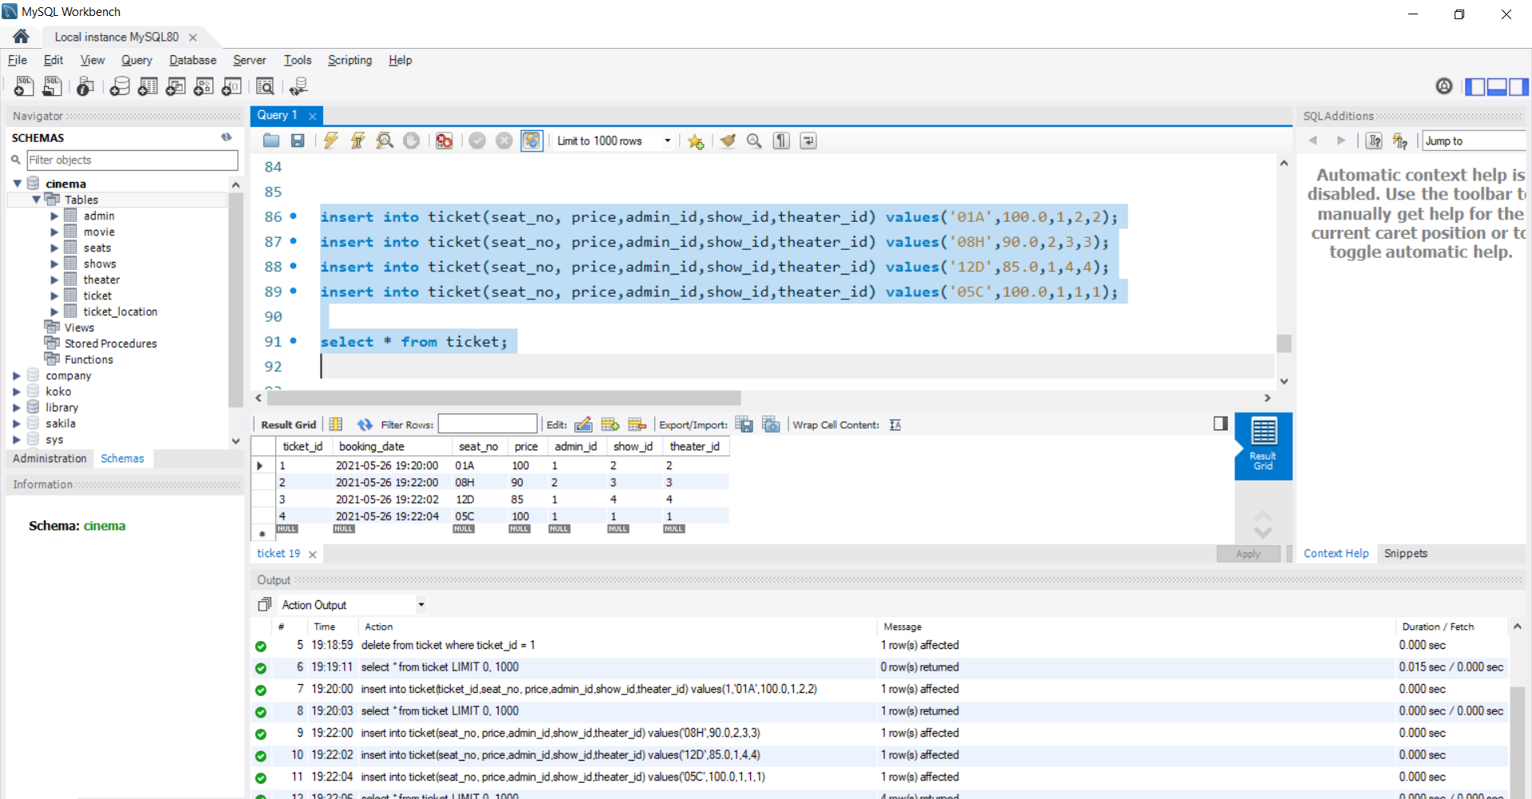

## **Insert Into Ticket_location Table**

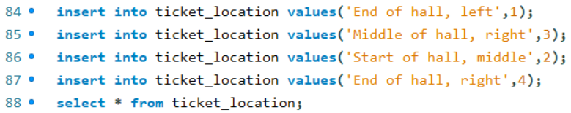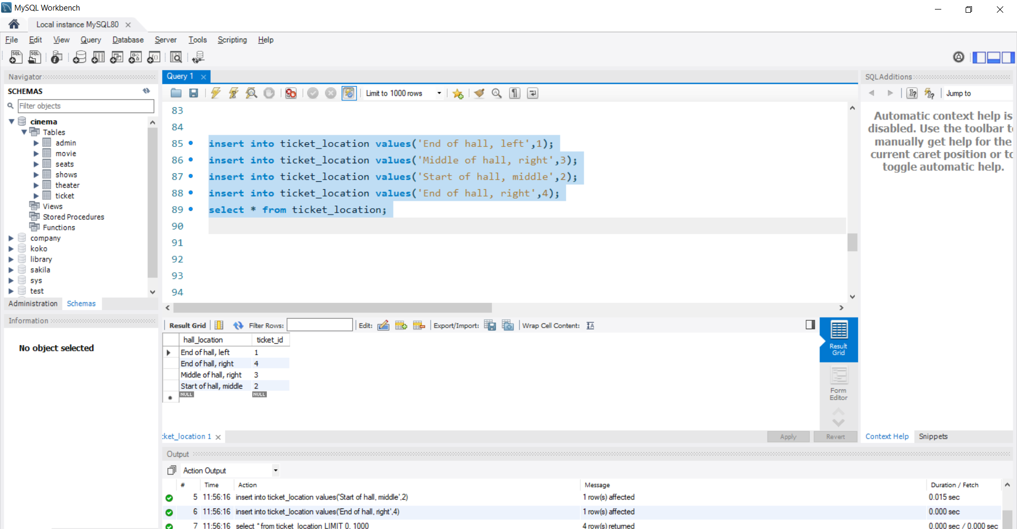

# **Project TABLE GROUP BY & JOIN**

## **GROUP BY Admin_ID**

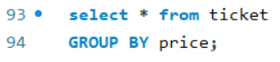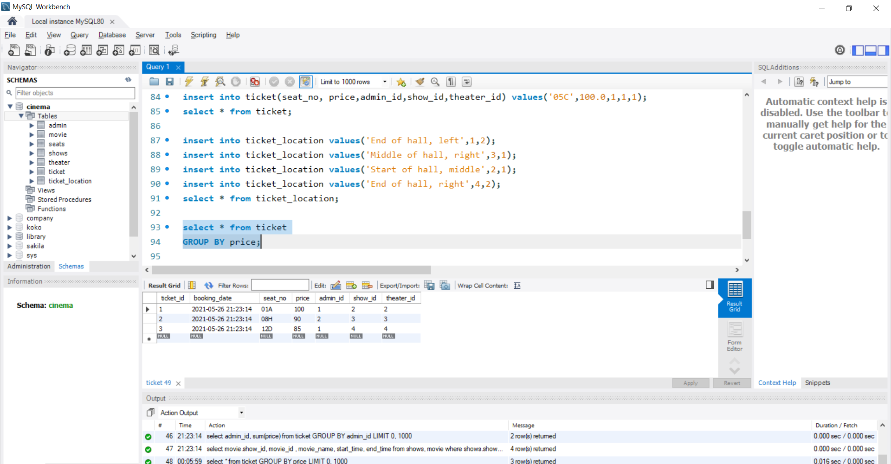

## **GROUP AVG Price BY Admin_ID**

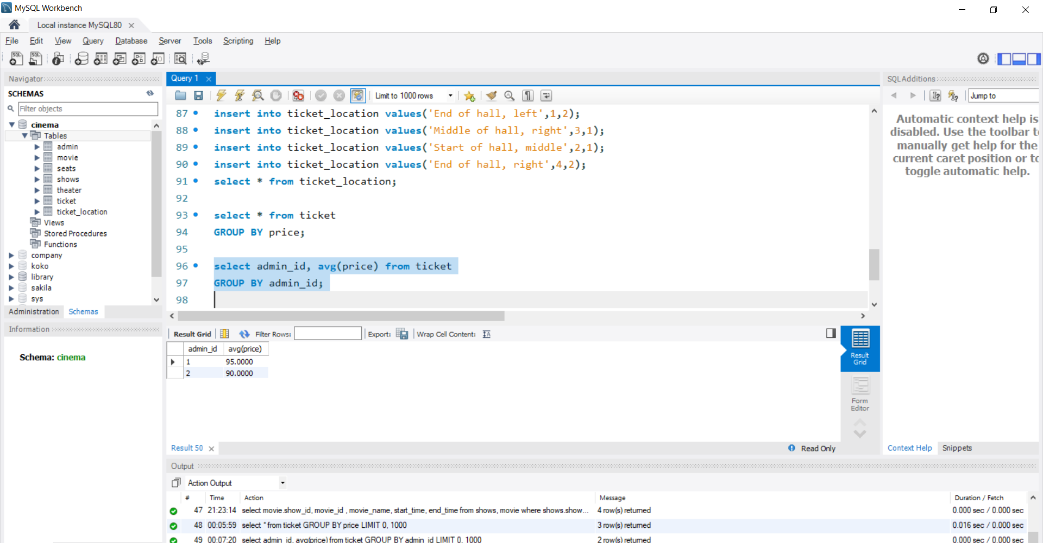

## **GROUP Sum Price BY Admin_ID**

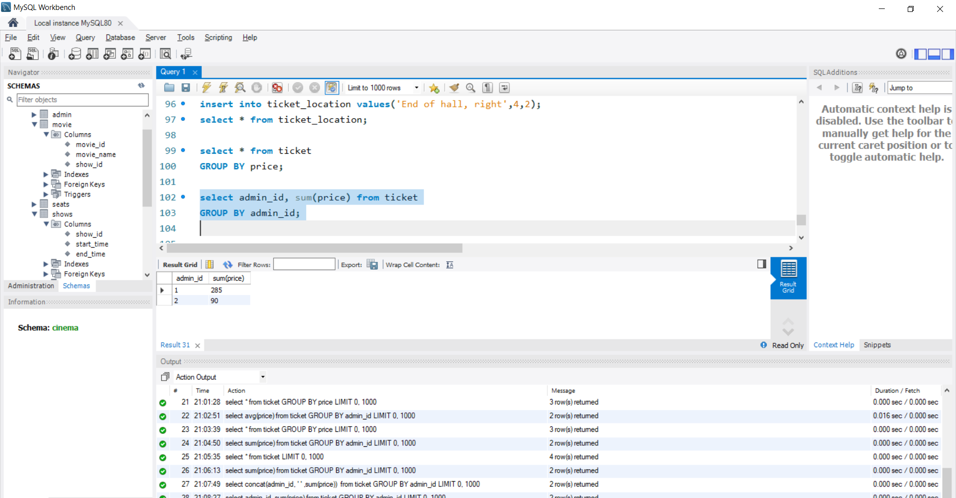

## **JOIN Movie Table and Show Table BY Show_ID**

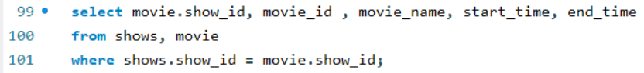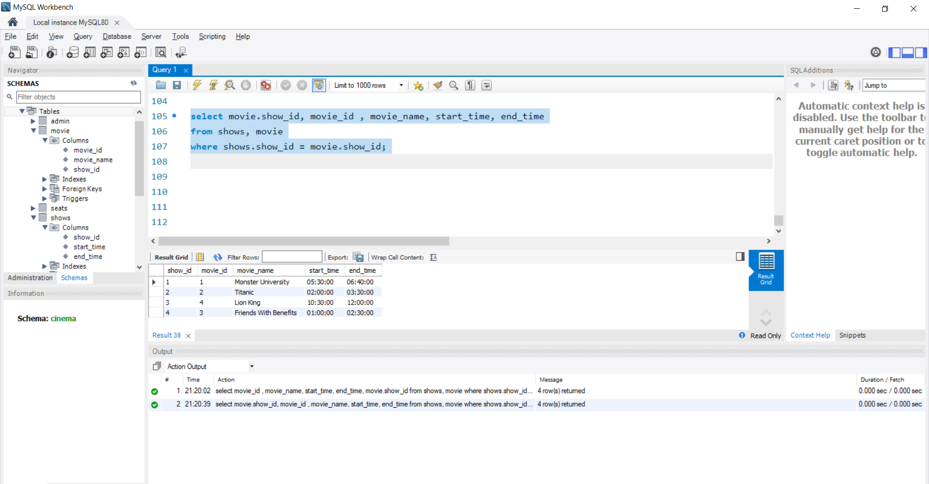

## **INNER JOIN Seats ON Theater**

